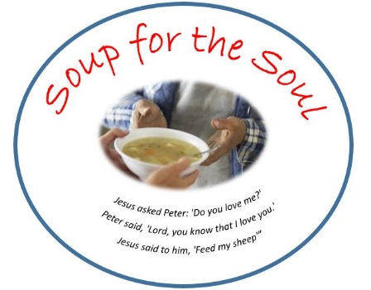

Cheesy Vegetable Chowder

(4 boiling potatoes, cut into 1/2-inch diced cubes
OR a 32 oz. bag of frozen Hash Brown CUBES)
32 oz. box of chicken broth
3 (10 oz.) cans condensed cheese soup
15 oz. sweet yellow corn
32oz. bag of frozen vegetables
3 cups milk
2 teaspoons salt
1 teaspoon fresh-ground black pepper

Bring the cubed potatoes (or cubed hash browns) to a boil, then reduce heat for 15 minutes. Drain excess liquid. Add chicken broth with 3 cans of condensed cheddar cheese soup and 3 cans of milk over medium-high heat to thoroughly mix. Add all other ingredients. Bring to a boil (stirring occasionally to prevent sticking), then simmer for 30 minutes.
*Cookies would be greatly appreciated, but not required*
Plastic containers are available at the Welcome Desk or Church office. Please freeze and bring to church.

For delivery on

To help deliver or for questions contact:
Randy Cox randy.cox@live.com (407) 402-9508

